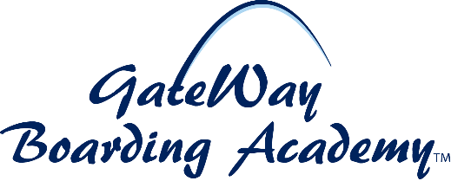
Position: GateWay Boarding Academy Program Manager (part-time)
Open: March 1, 2026
Eligibility: Must be a US citizen or permanent legal resident of the United States. Must successfully complete a background check including drug screening
Job Location: Camp Springs, Maryland
Compensation: Negotiable
Reports To: GBA Board President
Position Summary
GateWay Boarding Academy is seeking a part-time Program Manager, responsible for assisting in fulfilling the mission and objectives of GateWay. The Program Manager is responsible to manage the day-to-day operations of GateWay Boarding Academy, with the authority to carry out additional responsibilities assigned by the Board President.
Principal Duties and Job Functions
Responsibilities:
- Ensure implementation of programs’ objectives
- Recruiting qualified students and volunteers
- Managing the day-to-day program operations
- Supervising staff and volunteers
Experience and Qualifications Requirements
- At least a bachelor’s degree from an accredited college or university
- Strong oral and written communication skills
- Ability to manage competing priorities
- Excellent interpersonal skills
- Excellent computer skills
- Ability to handle and protect restricted and confidential information
Directions for Applying: Please complete the GateWay Employment Application Form and email completed application, along with your resume, to contactus@gatewayboardingacademy.org

